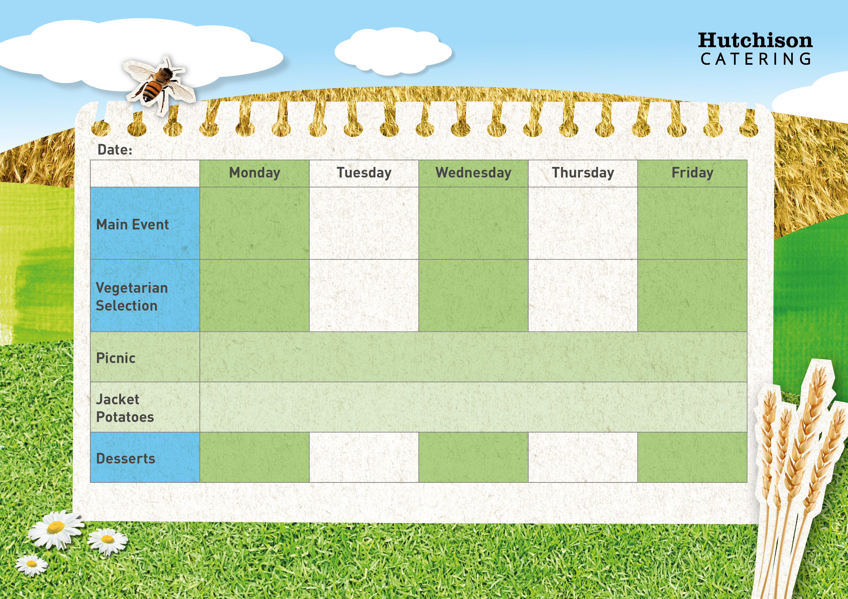

**Freshly Prepared Sandwich, Roll or Wrap served with Mixed Salad**

**and the Dessert of the Day, Yoghurt or Fresh Fruit**

**Crispy Baked Jacket Potato with a Choice of Baked Beans (VE), Tuna Mayo or Cheese (V) with Mixed Salad**

**Dessert of the Day, Yoghurt or Fresh Fruit**

Oaty Biscuit (VE)

Chocolate Crunch Cookies (VE)

Margherita Pizza served with Homemade Potato Wedges & Sweetcorn or Cucumber Sticks (V)

**Week 3**

Roast Gammon in Gravy with Roast Potato, Yorkshire Pudding & Carrots or Broccoli

Meatballs in Tomato Sauce with Pasta & Broccoli or Green Beans

Homemade Chicken Korma Curry with Rice & Peas or Sweetcorn

Popcorn Chicken with Chips & Peas or Baked Beans

Cheese & Bean Pinwheel with Chips & Peas or Baked Beans (V)

Cheese & Tomato Tortilla Stack with Rice & Peas or Sweetcorn (V)

Quorn Fillet in Gravy with Roast Potato, Yorkshire Pudding & Carrots or Broccoli (V)

Quorn Korma with Rice & Broccoli or Green Beans (VE)

Quorn Burger served with Homemade Potato Wedges & Sweetcorn or Cucumber Sticks (V)

Ice Cream with Mango (V)

Iced Sponge School Cake (V)

Strawberry Bun with Fresh Fruit (V)

**Key: V – Vegetarian, VE – Vegan**

**Available Daily:** Water, Bread, Salad, Fresh Fruit, and Yoghurt