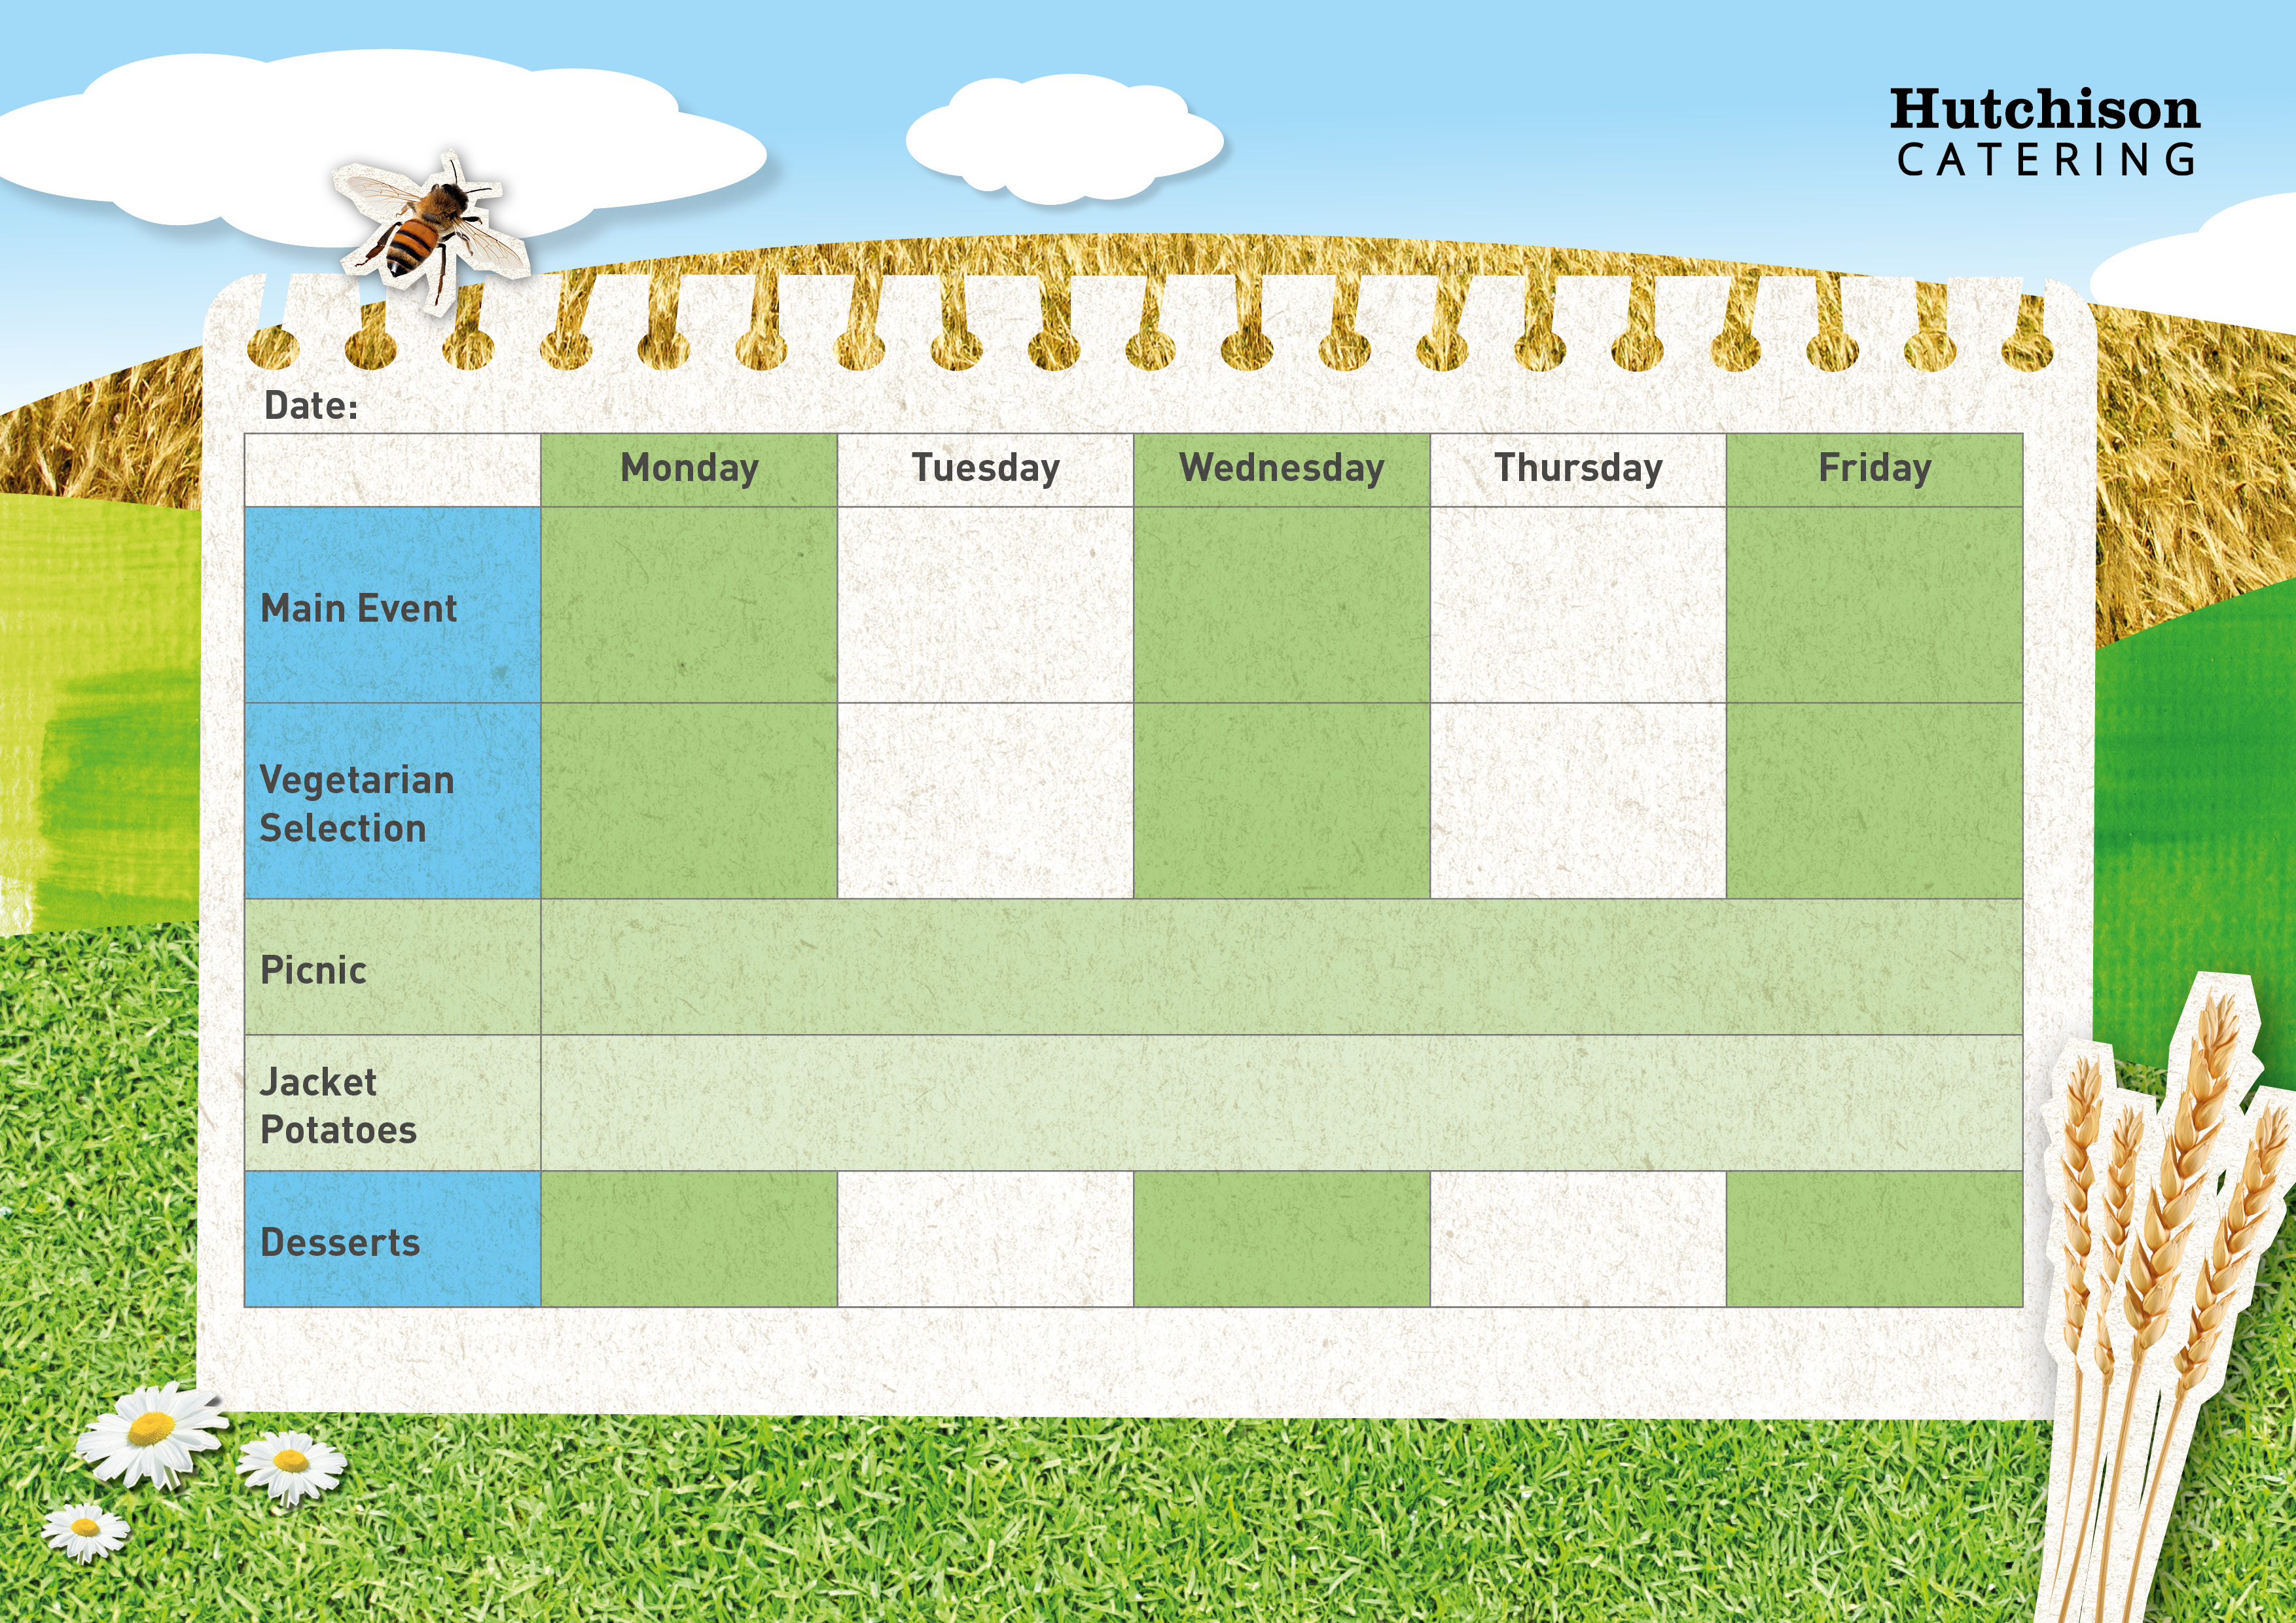

**Week 2**

**Key: V – Vegetarian, VE – Vegan**

**Available Daily:** Water, Bread, Salad, Fresh Fruit, and Yoghurt

Very Berry Jelly (VE)

Chocolate Muffin (V)

Flapjack (VE)

Lamington Cake (V)

Melting Moments with Fresh Fruit (V)

**Crispy Baked Jacket Potato with a Choice of Baked Beans (VE), Tuna Mayo or Cheese (V) with Mixed Salad**

**Dessert of the Day, Yoghurt or Fresh Fruit**

**Freshly Prepared Sandwich, Roll or Wrap served with Mixed Salad**

**and the Dessert of the Day, Yoghurt or Fresh Fruit**

Cheese & Tomato Panini with Chips & Baked Beans or Peas (V)

Vegetarian Pasta Bolognaise with Broccoli or Carrot Sticks (VE)

Quorn Sausage in Gravy with Mashed Potatoes & Carrots or Cauliflower (VE)

Macaroni Cheese with Garlic Bread & Peas or Green Beans (V)

Tomato & Basil Pasta with Cucumber Sticks or Sweetcorn (V)

Margherita Pizza with Potato Wedges & Cucumber Sticks or Sweetcorn

Chicken Katsu Curry served with Rice & Peas or Green Beans

Pork Sausage in Gravy with Mashed Potatoes & Carrots or Cauliflower

Italian Chicken Pasta with Broccoli or Carrot Sticks

Oven Baked Fish with Chips & Baked Beans or Peas