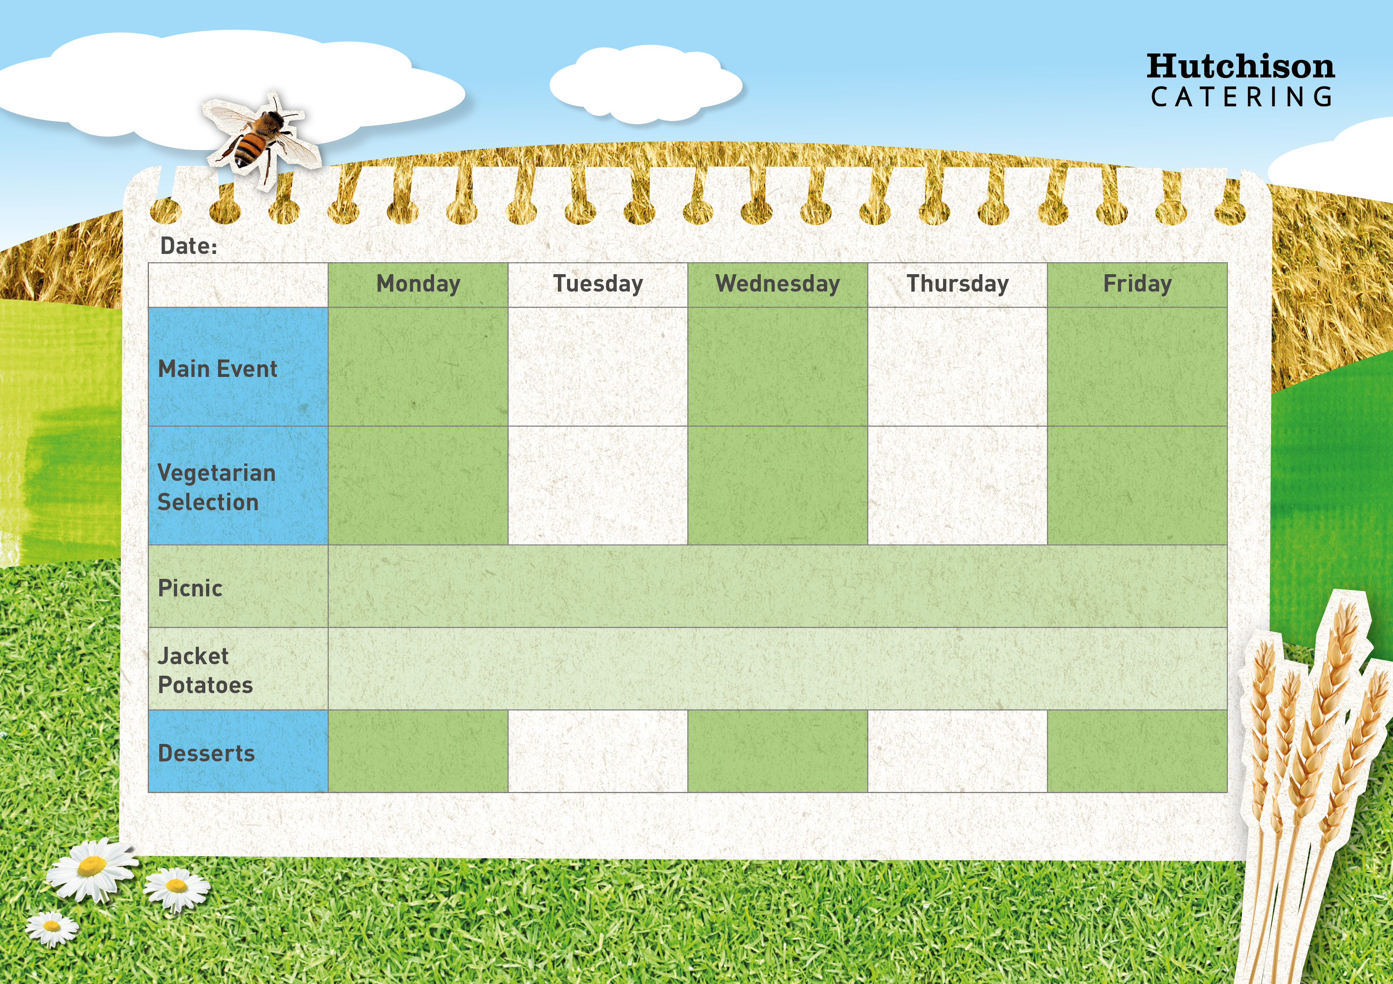

**Week 1**

**Key: V – Vegetarian, VE – Vegan**

**Available Daily:** Water, Bread, Salad, Fresh Fruit, and Yoghurt

Ice Cream with Mandarins (V)

Blueberry Muffin (V)

Chocolate and Beetroot Brownie (V)

Shortbread (VE) & with Fresh Fruit

Strawberry Whip (V)

**Crispy Baked Jacket Potato with a Choice of Baked Beans (VE), Tuna Mayo or Cheese (V) with Mixed Salad (VE)**

**Dessert of the Day, Yoghurt (V) or Fresh Fruit (VE)**

**Freshly Prepared Sandwich, Roll or Wrap served with Mixed Salad**

**and the Dessert of the Day, Yoghurt or Fresh Fruit**

Quorn Nuggets with Chips & Baked Beans or Peas (VE)

Tomato & Basil Pasta with Homemade Bread & Cucumber Sticks or Sweetcorn (VE)

Quorn Fillet in Gravy with Roast Potato, Yorkshire pudding & Carrots or Broccoli

Vegetarian Enchiladas served with Rice & Peas or Salad (V)

Cheese & Bean Wrap served with Homemade Potato Wedges & Carrot Sticks or Sweetcorn (VE)

Margherita Pizza served with Homemade Potato Wedges & Carrot Sticks or Sweetcorn (V)

BBQ Chicken Wrap served with Rice & Peas or Salad

Roast Pork in Gravy with Roast Potato, Yorkshire Pudding & Carrots or Broccoli

Beef Lasagne served with Homemade Bread & Cucumber Sticks or Sweetcorn

Popcorn Chicken with Chips & Baked Beans or Peas